git ---version

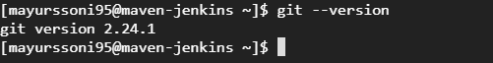

Git config.

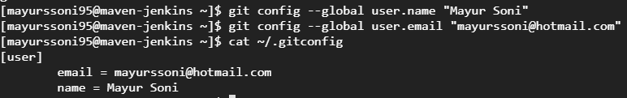

Git init



Git add filename

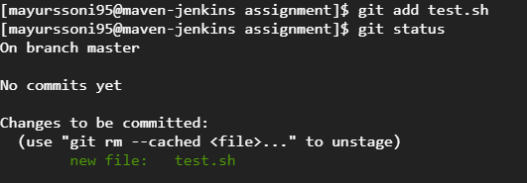

git commit -m "commit message"

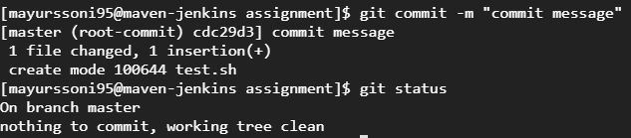

git remote add origin https://github.com/mayurssoni/assignment.git



Git push origin master

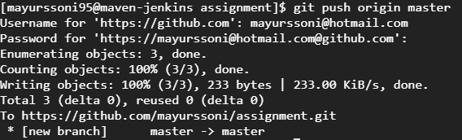

Git branch

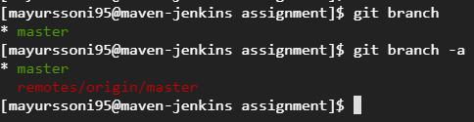

Git branch test1

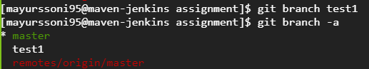

Git branch –d test1

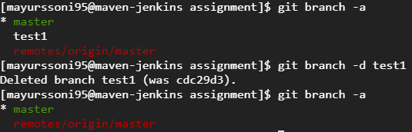

Git checkout –b test2

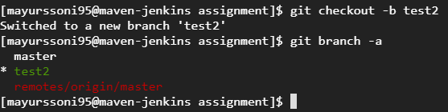

Git merge test (while in master branch)

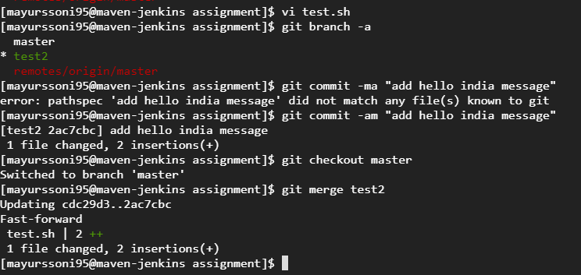

Git stash

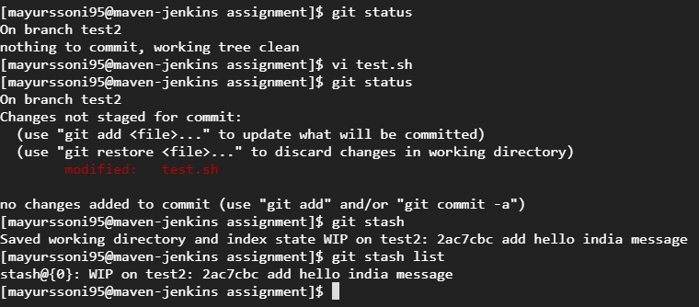

git stash list



git stash apply stash@{0}

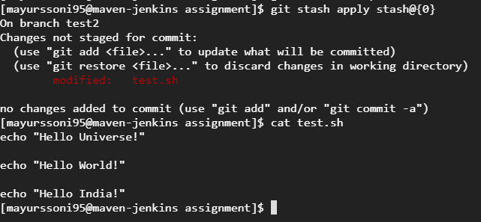

Git stash pop

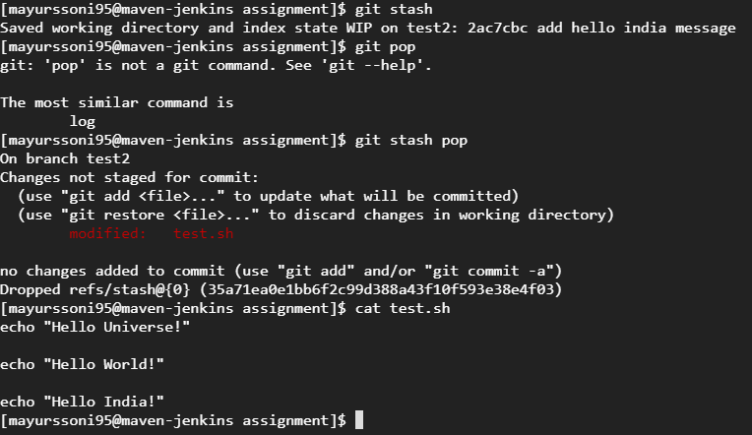

Git log, git log –oneline

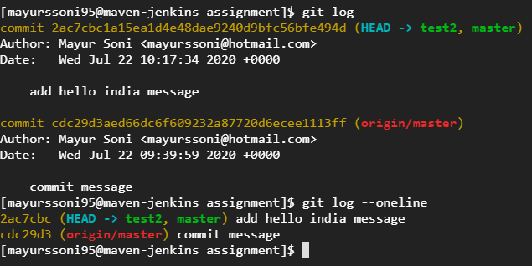

Git rebase master

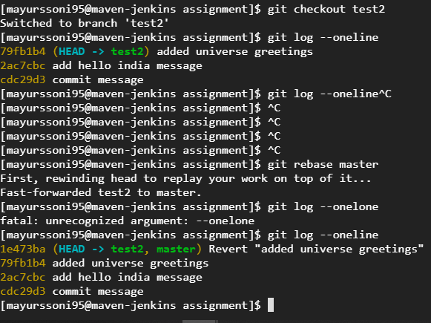

https://github.com/mayurssoni/assignment.git